Written Lab 5: Summarization and Troubleshooting

Key Networking Terms:

1. Variable Length Subnet Mask (VLSM)- a type of subnetting that allows one to break up a network into different sized chunks, instead of all chunks being a uniform size. This is important because it allows for more efficient subnetting of a network.
2. Summarizing/route-aggregation – The process of “combining” different networks to be seen as one network in a routing table. This allows routers that point to these networks to forward traffic faster and maintain smaller routing tables; saving time and memory.
3. Ping—An extremely useful command for troubleshooting. It checks in on specified addresses to see if a connection can be made. The success or failure of a ping on certain addresses within a network can provide beneficial information.

Procedures:

Review Questions:

1. On a VLSM network, which mask should you use on point-to-point WAN links in order to reduce the waste of IP addresses?

One should use a /30 for max efficiency with point to point WAN links. [D]

1. In the network shown in the diagram, how many computers could be in Network B?

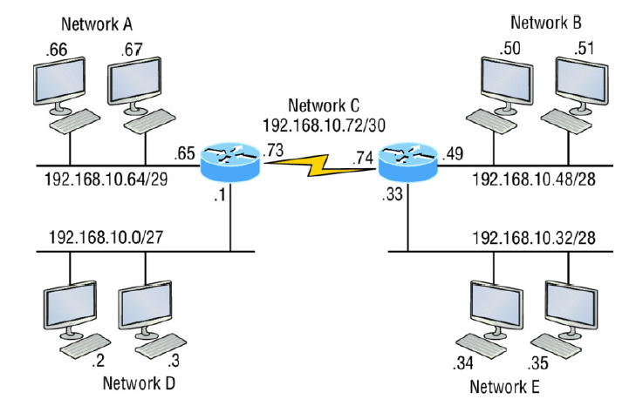

Network B can only have a max of 14 computers, because a /28 gives 16 addresses, then only 14 of those are actually usable. [C]

1. What command displays the ARP table on a CISCO router?

The “show ip arp” command will bring up the ARP table on a cisco Router. [A]

Conclusions and Discussion:

The readings for this chapter were very insightful. Honestly, this book is great because reading it doesn’t feel like a chore, but more like a conversation. The speaker likes to joke with the reader; it definitely helps me stay engaged. Now to get back on track, this chapter revealed information that made sense but I have never thought about. I know each router can’t contain all possible routes, and packet switching and forwarding has been explained in one of my other classes, but I was unaware how the routers passed this information to each other. Summarization makes packet forwarding between routers make much more sense, in terms of available space on a routing table. I am curious about how far summarization can go; like if all the IP addresses in one country can be labeled as such; although I bet we rarely have to go across country for information because of network distribution centers (servers?).

I thought it was really interesting that some of the troubleshooting steps had definite answers on what an issue would or wouldn’t be depending on the ping result for each address. In nursing, I was very used to answers not always being so definite, because of how strange and similar biological reactions can be; it is nice for things to be much more certain for a change. I wouldn’t have even thought about reinstalling TCP IP if pinging loopback failed.

I look forward to learning more on how to fix issues in networking.

Feedback:

